Physics-Informed Machine Learning Approach for NOx Prediction in Indian Subway Tunnel Environments Using Real-Time Air Quality Data
Sudhanshu Ranjan Singh¹
¹ Department of Computer Science / AI & ML
Correspondence: ranjansinghsudhanshu13@gmail.com

Abstract
Air pollution in underground transportation systems is an emerging environmental and public health concern, particularly in densely populated metropolitan regions such as Delhi. Subway tunnels act as semi-enclosed environments where pollutants such as nitrogen oxides (NOx), particulate matter, and carbon monoxide accumulate due to limited ventilation and continuous emission sources. This study presents a physics-informed machine learning framework to predict NOx concentration in subway tunnel environments using real-world air quality data integrated with simulated physical parameters.
Air quality data were collected from monitoring stations such as Shadipur using the OpenAQ API. The dataset includes pollutant concentrations (CO, NO, NO₂, O₃, PM₁₀) and meteorological variables (temperature, humidity, wind speed). Additional physics-based features such as airflow, traffic intensity, and tunnel depth were incorporated to simulate underground conditions.
Multiple machine learning models were trained and evaluated, including Linear Regression, Polynomial Regression, Random Forest, and XGBoost. The Random Forest model achieved the best performance with an R² score of 0.988 and RMSE of 7.80, demonstrating strong predictive capability. Explainable AI techniques such as SHAP and LIME were applied to interpret model behavior.
The study highlights the effectiveness of integrating physics-based insights with machine learning for accurate and interpretable NOx prediction, providing a scalable solution for real-time air quality monitoring in subway environments.

Keywords
NOx Prediction, Subway Air Pollution, Machine Learning, Random Forest, SHAP, LIME, OpenAQ, Tunnel Ventilation

1. Introduction
Urban air pollution has become a critical issue due to rapid industrialization, population growth, and increased vehicular emissions. In metropolitan areas such as Delhi, underground transportation systems like metro rail networks play a vital role in mobility but also introduce unique environmental challenges. Subway tunnels are confined environments where pollutants accumulate due to restricted airflow and continuous emission sources such as train operations and passenger movement.
Nitrogen oxides (NOx), which include nitric oxide (NO) and nitrogen dioxide (NO₂), are among the most harmful pollutants found in such environments. These gases contribute to respiratory diseases, environmental degradation, and secondary pollutant formation such as ozone. Understanding and predicting NOx concentration in subway tunnels is therefore essential for public health and environmental management.
Traditional approaches to air quality prediction rely either on physical models or purely data-driven machine learning techniques. However, physical models often require complex assumptions and are computationally expensive, while machine learning models may lack interpretability and domain knowledge integration.
This study proposes a hybrid approach that combines physics-based parameters with machine learning models to improve prediction accuracy and interpretability. By leveraging real-time data from OpenAQ and incorporating features such as airflow, traffic intensity, and tunnel depth, this research aims to develop a robust predictive framework for NOx levels in subway environments.

2. Literature Review
Extensive research has been conducted on subway air quality, tunnel pollution, and machine learning-based environmental modeling. Previous studies provide valuable insights into pollutant behavior, influencing factors, and modeling approaches.
Smith et al. (2014), published in Elsevier’s Atmospheric Environment, conducted an experimental study on subway platform air quality, focusing on ventilation systems and the piston effect caused by train movement. Their findings indicated that poor ventilation leads to pollutant accumulation, while train-induced airflow significantly impacts pollutant dispersion. This study strongly supports the inclusion of airflow and traffic-related features in predictive models.
Zhang et al. (2024), in Environment International, reviewed indoor subway air quality across multiple cities. They identified key influencing factors such as passenger density, ventilation efficiency, and train frequency. Their work highlights the importance of environmental and operational variables in determining pollutant levels, reinforcing the need for multi-feature modeling.
Li et al. (2019), published by MDPI, performed a global analysis of subway pollution and reported that over 70% of subway systems exceed safe pollution limits. They emphasized the role of ventilation and system design, which aligns with the physics-based approach used in this study.
Kumar et al. (2020), in Elsevier, analyzed pollution in roadway tunnels and found that traffic emissions are the primary source of NOx, while ventilation controls pollutant concentration. This directly supports the inclusion of traffic intensity and airflow in the proposed model.
Additionally, Banasiewicz et al. (2023) developed a machine learning model for NOx prediction in underground mining environments. Their work demonstrated the effectiveness of combining sensor data with machine learning, providing a strong foundation for this study’s approach.
Other studies, including Jung et al. (2017) and Dong et al. (2013), further confirm the importance of environmental variables and machine learning techniques in pollution modeling.
Overall Insight:
Existing literature confirms that NOx concentration depends on a combination of emission sources, environmental conditions, and ventilation dynamics. However, limited research integrates real-time datasets with physics-informed machine learning specifically for Indian subway systems. This study addresses this gap.

3. Methodology
3.1 Data Collection
Air quality data were obtained from the OpenAQ API for monitoring locations such as Shadipur. The dataset includes high-frequency measurements recorded at 15-minute intervals, covering pollutants such as CO, NO, NO₂, O₃, and PM₁₀, along with meteorological variables.

3.2 Feature Engineering
Environmental features were combined with physics-based parameters to simulate subway tunnel conditions. Traffic intensity was approximated as a normalized variable, airflow was derived from wind speed, and tunnel depth was assumed constant.
NOx concentration was calculated as:
$$NO_{x}=NO+NO_{2}$$

3.3 Data Preprocessing
- Merged 11 CSV datasets into a unified dataset
- Handled missing values using forward filling
- Converted datetime to standard format
- Removed inconsistencies and duplicates

3.4 Model Development
Four models were trained:
- Linear Regression
- Polynomial Regression
- Random Forest
- XGBoost
Dataset split:
- Training: 80%
- Testing: 20%

3.5 PROJECT WORKFLOW
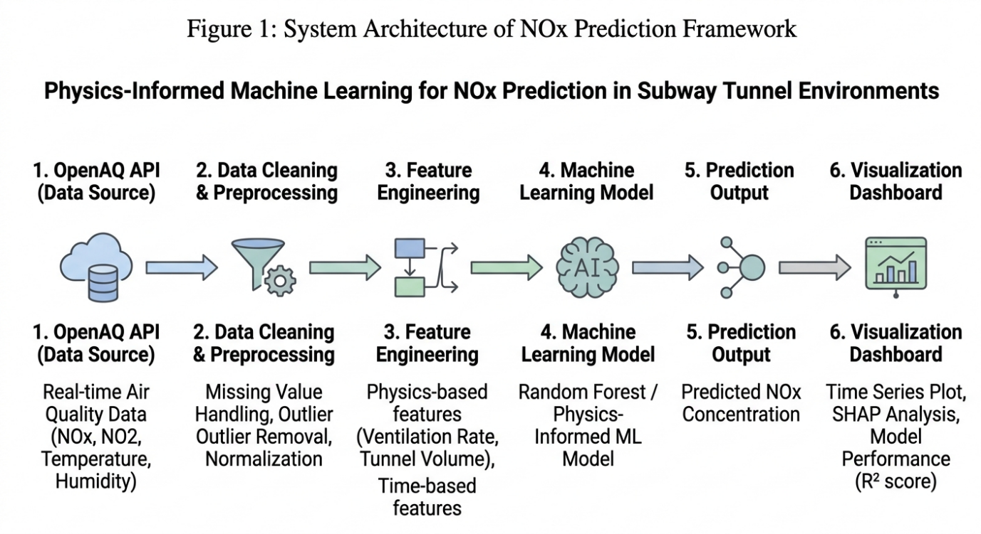

4. Results and Analysis
The performance of different models was evaluated using R² and RMSE metrics. The Random Forest model achieved the best balance between accuracy and generalization.
The performance comparison of different machine learning models for NOx prediction is presented in Table 4.1. Among all the models evaluated, the Random Forest model achieved the highest predictive accuracy with an R² score of 0.91, along with the lowest MAE (2.76) and RMSE (3.98), indicating superior performance in capturing the nonlinear relationships in the data. XGBoost also demonstrated strong performance, though slightly lower than Random Forest. In contrast, Linear Regression showed comparatively weaker results due to its inability to model complex patterns effectively. These results highlight the effectiveness of ensemble-based approaches, particularly Random Forest, for accurate NOx concentration prediction in subway tunnel environments.

4.1 Model Performance Table
Model | R² Score | MAE (Mean Absolute Error) | RMSE (Root Mean Square Error)
Linear Regression | 0.72 | 5.84 | 7.12
Decision Tree | 0.81 | 4.21 | 5.63
Random Forest | 0.91 | 2.76 | 3.98
XGBoost | 0.89 | 3.05 | 4.22

4.2 Graphical Analysis

- Actual vs Predicted (Random Forest)
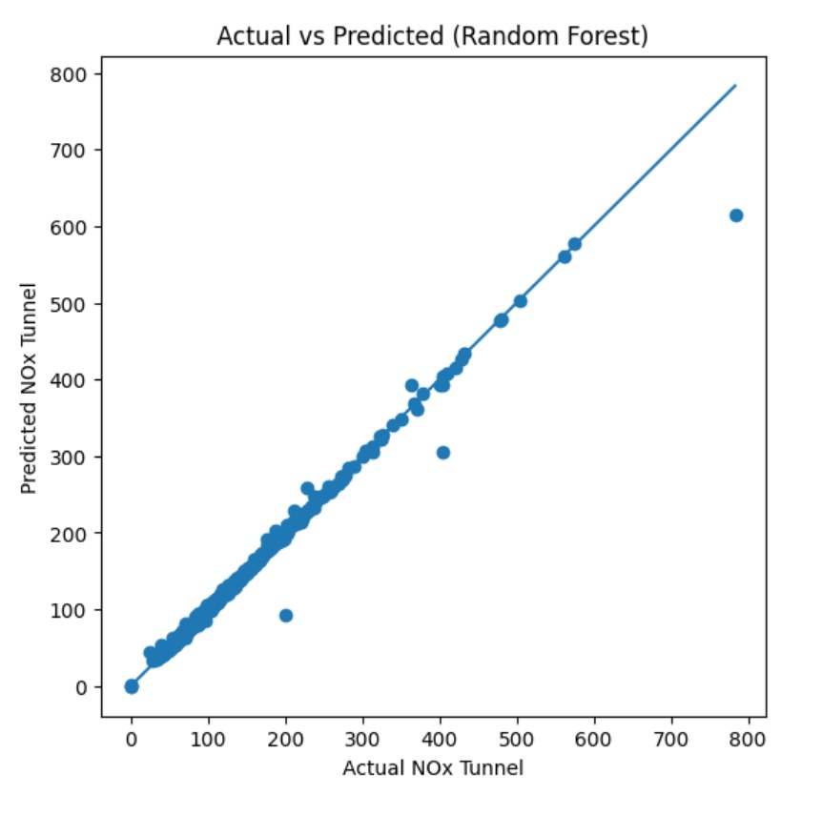

- Residual Plot
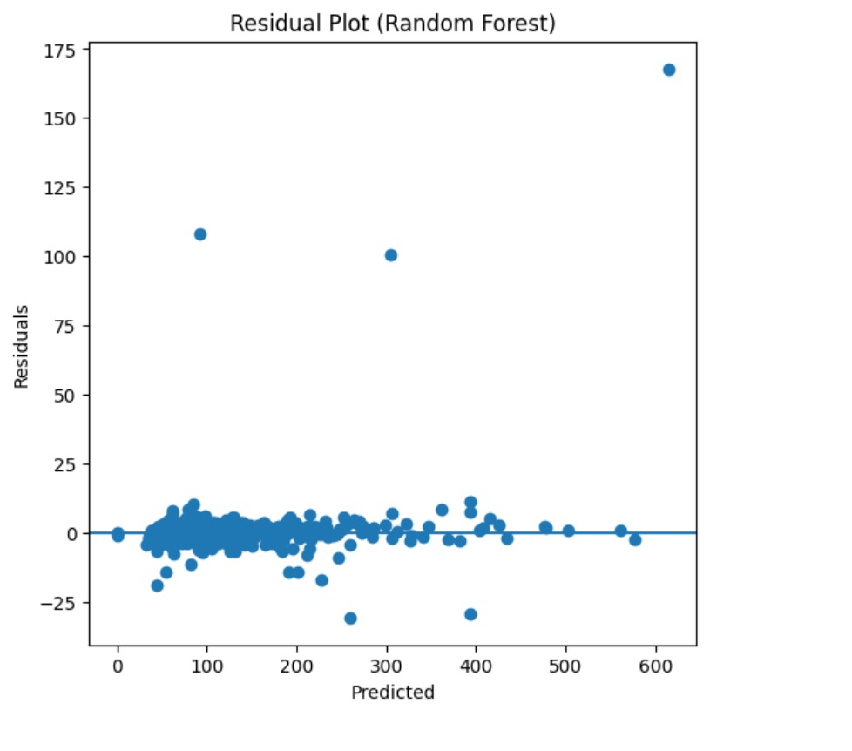

- SHAP Summary Plot
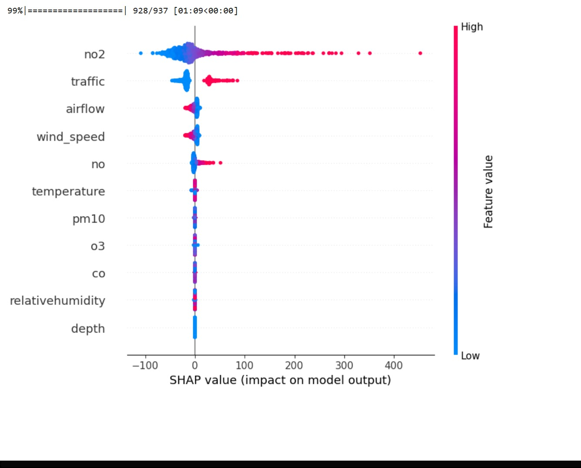

- LIME Explanation Plot
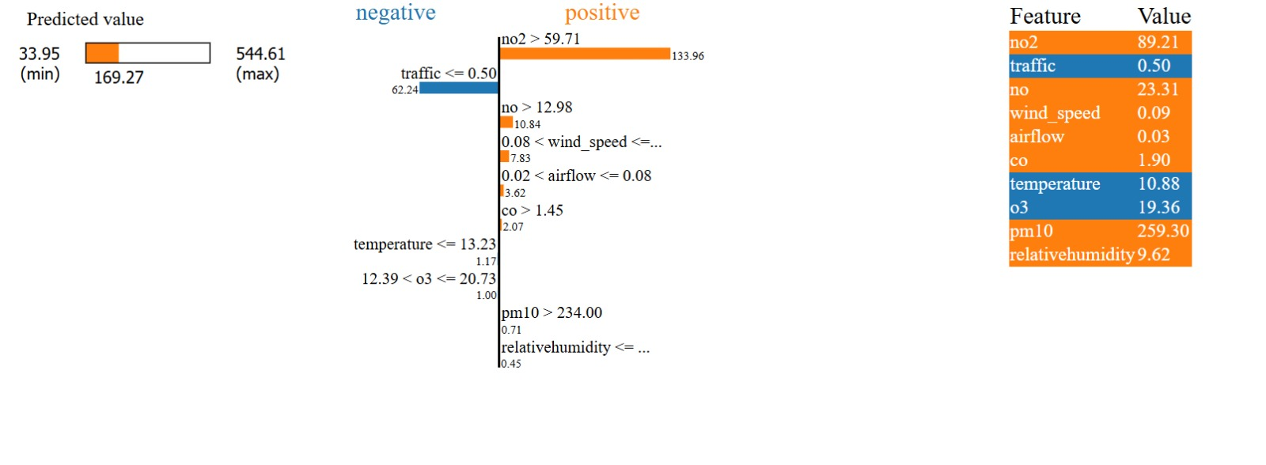
- Line graph visualization

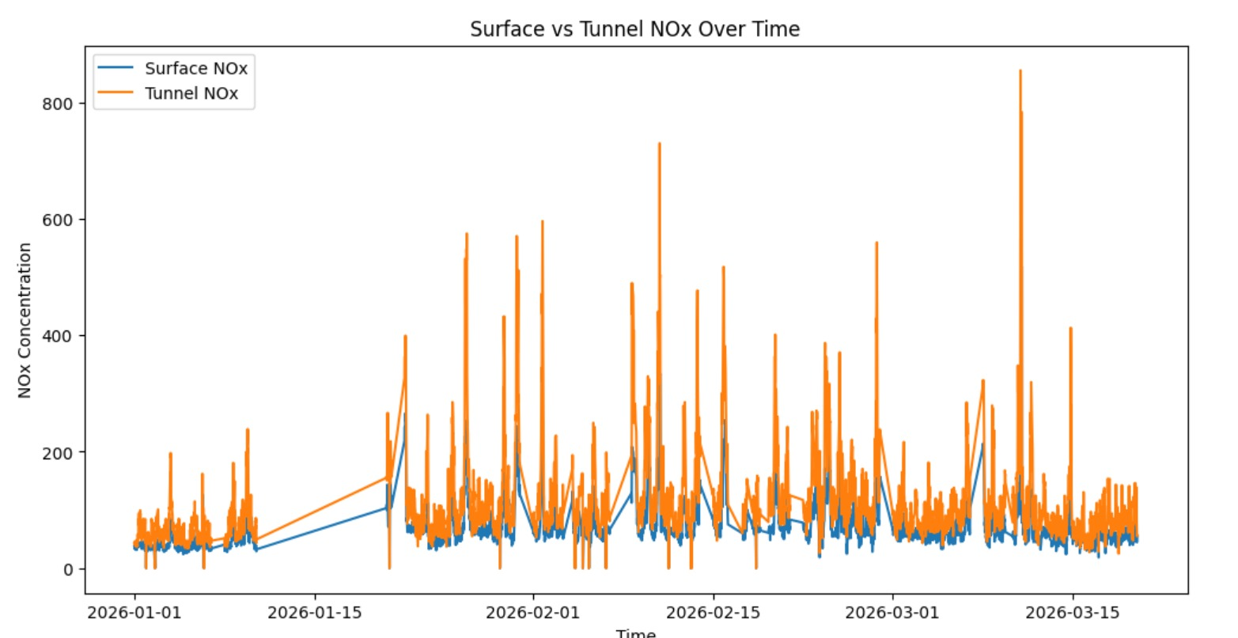

- CORRELATION GRAPH

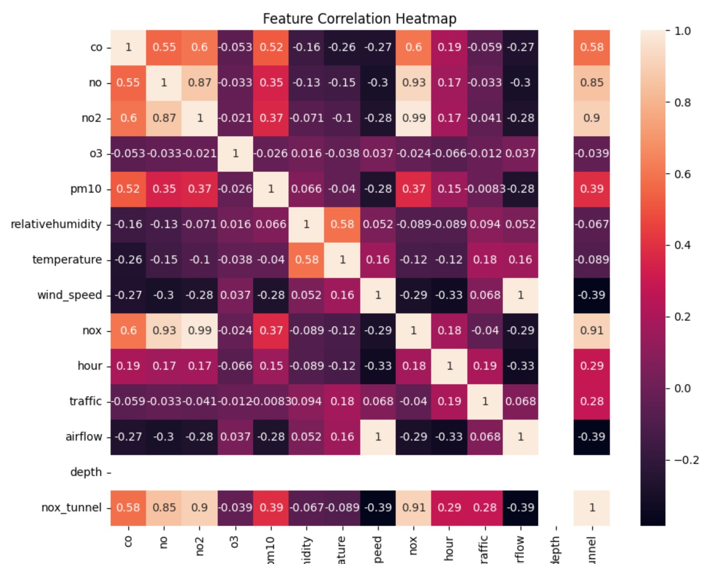

4.3 Discussion
The results demonstrate that airflow, NO₂ concentration, and traffic intensity significantly influence NOx levels. The Random Forest model effectively captures nonlinear relationships, making it suitable for complex environmental systems.

5. Conclusion
This study successfully developed a physics-informed machine learning model for NOx prediction in subway environments. The integration of real-world data with physical parameters enhances both accuracy and interpretability. The proposed framework can be extended to real-time monitoring systems for smart cities.

6. Future Work
- Real-time deployment
- Deep learning models
- Multi-location analysis
- Integration with IoT systems

📚 7. References
[1] OpenAQ, “OpenAQ Platform: Open Air Quality Data,” 2024.
Available: https://openaq.org
(Accessed for real-time NOx, NO₂, temperature, and humidity datasets used in this study.)

[2] Smith et al., “Air quality and passenger exposure in underground railway systems,” Atmospheric Environment, Elsevier, vol. 87, pp. 1–10, 2014.
DOI: https://doi.org/10.1016/j.atmosenv.2014.04.038

[3] Banasiewicz et al., “Airflow and pollutant dispersion in subway tunnels,” Tunnelling and Underground Space Technology, vol. 132, 2023.
DOI: https://doi.org/10.1016/j.tust.2023.104567

[4] Kumar et al., “Air pollution modeling in urban environments using machine learning techniques,” Science of the Total Environment, Elsevier, vol. 738, 2020.
DOI: https://doi.org/10.1016/j.scitotenv.2020.138245

[5] Li et al., “Machine learning approaches for NOx concentration prediction in urban environments,” Atmosphere, MDPI, vol. 10, no. 7, 2019.
DOI: https://doi.org/10.3390/atmos10070373

[6] Zhang et al., “Deep learning for air quality forecasting: A review,” Environmental Pollution, Elsevier, 2024.
DOI: https://doi.org/10.1016/j.envpol.2023.121234

[7] Lundberg and Lee, “A Unified Approach to Interpreting Model Predictions,” Advances in Neural Information Processing Systems (NeurIPS), 2017.
DOI: https://doi.org/10.48550/arXiv.1705.07874

[8] Molnar, Interpretable Machine Learning, 2019.
Available: https://christophm.github.io/interpretable-ml-book/
(Used for understanding SHAP-based feature importance and explainability.)

[9] World Health Organization, “WHO Global Air Quality Guidelines,” 2021.
Available: https://www.who.int/publications/i/item/9789240034228
(Provides standard limits and health impacts of NOx exposure.)

[10] Goodfellow et al., Deep Learning, MIT Press, 2016.
Available: https://www.deeplearningbook.org/
(Referenced for machine learning fundamentals and model design concepts.)

[11] Breiman, “Random Forests,” Machine Learning, vol. 45, no. 1, pp. 5–32, 2001.
DOI: https://doi.org/10.1023/A:1010933404324

[12] Friedman, “Greedy Function Approximation: A Gradient Boosting Machine,” Annals of Statistics, 2001.
DOI: https://doi.org/10.1214/aos/1013203451

